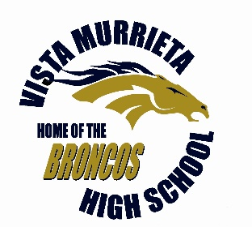  CHARACTER  LEADERSHIP  ATTITUDE  SCHOLARSHIP SERVICE  Principal  Celeste Scallion  Assistant Principals  Brianna Burow  Lloyd Dunn  Shane Sands  Rosa Velardez  Tamara Waddleton  Assistant Principal Athletics  Carl Galloway  Activities Director  Shannon Kush  Counselors  Karen Candaele  Claudia Hill  Debra Kimble  Silvia Osorio  Aurora Padilla  Eric Peterson  Dione Tyler  Sandie Valenzuela | Vista Murrieta High School  A California Gold Ribbon School and…a Tradition of CLASS...  Study Skills Class Syllabus  Course Description:  The Study Skills class is designed to equip students with essential strategies and techniques to enhance their learning and academic success. Students will develop effective study habits, time management skills, note-taking strategies, and critical thinking abilities.  Course Objectives:  - Develop effective study techniques for different subjects.  - Enhance time management and organizational skills.  - Improve note-taking and active reading skills.  - Strengthen critical thinking and problem-solving abilities.  - Active engagement in class discussions, activities, and exercises.  - Completion of assignments and practice activities.  - Respectful communication with the teacher and peers.  - Adherence to classroom rules and expectations.  Communication:  Students are encouraged to ask questions during class or visit the teacher during office hours.  Email communication for clarifications and inquiries is welcome.  Any important announcements will be shared through Canvas.  Support and Extra Help:  Office hours: Thursdays W235 – Appointment only  Academic Integrity:  Plagiarism and cheating are strictly prohibited. All work should be your own.  Accessibility and Accommodations:  Disclaimer:  This syllabus is subject to change at the discretion of the teacher to accommodate the needs of the class.  By participating in this class, you acknowledge that you have read, understood, and agree to abide by the information provided in this syllabus.  Student Signature: ____________________________ Date: ______________  Parent/Guardian Signature: _____________________ Date: ______________  Teacher Signature: _____________________________ Date: ______________
 | Vista Murrieta High School 28251 Clinton Keith Road, Murrieta, CA 92563 (951)894-5750

